Code:

%Nicholas Fong CSCI 166 MP 5 3/5/17

%data

x1 = [0,0.15,0.31,0.5,0.6,0.75];

x1New = 0:0.05:0.75;

y1 = [1,1.004,1.031,1.117,1.223,1.422];

x2 = [4,4.2,4.5,4.7,5.1,5.5,5.9,6.3,6.8,7.1];

x2New = 4:0.05:7.1;

y2 = [102.56,113.18,130.11,142.05,167.53,195.14,224.87,256.73,299.5,326.72];

x3 = [0.2,0.3,0.6,0.9,1.1,1.3,1.4,1.6];

x3New = 0.2:0.05:1.6;

y3 = [0.050446,0.098426,0.33277,0.7266,1.0972,1.5697,1.8487,2.5015];

%does the regression and plots it

function regression(x,xNew,y)

linRegCoefficients = polyfit(x,y,1);

quadRegCoefficients = polyfit(x,y,2);

fprintf("x =");

disp(x);

fprintf("y =");

disp(y);

fprintf("linear regression coefficients =");

disp(linRegCoefficients);

fprintf("quadratic regression coefficients =");

disp(quadRegCoefficients);

yNewLinReg = polyval(linRegCoefficients, xNew);

yNewQuadReg = polyval(quadRegCoefficients, xNew);

plot(x,y,'o',xNew,yNewLinReg,xNew,yNewQuadReg);

end;

%run everything

figure(1);

fprintf('Figure 1:\n');

regression(x1,x1New,y1);

figure(2);

fprintf('\nFigure 2:\n');

regression(x2,x2New,y2);

figure(3);

fprintf('\nFigure 3:\n');

regression(x3,x3New,y3);

Output:

Figure 1:

x = 0.00000 0.15000 0.31000 0.50000 0.60000 0.75000

y = 1.0000 1.0040 1.0310 1.1170 1.2230 1.4220

linear regression coefficients = 0.52810 0.92951

quadratic regression coefficients = 1.14733 -0.32570 1.01134

Figure 2:

x = 4.0000 4.2000 4.5000 4.7000 5.1000 5.5000 5.9000 6.3000 6.8000 7.1000

y = 102.56 113.18 130.11 142.05 167.53 195.14 224.87 256.73 299.50 326.72

linear regression coefficients = 72.085 -194.138

quadratic regression coefficients = 6.6182 -1.1435 1.2356

Figure 3:

x = 0.20000 0.30000 0.60000 0.90000 1.10000 1.30000 1.40000 1.60000

y = 0.050446 0.098426 0.332770 0.726600 1.097200 1.569700 1.848700 2.501500

linear regression coefficients = 1.66554 -0.51246

quadratic regression coefficients = 1.129424 -0.311403 0.085144

Plot 1:

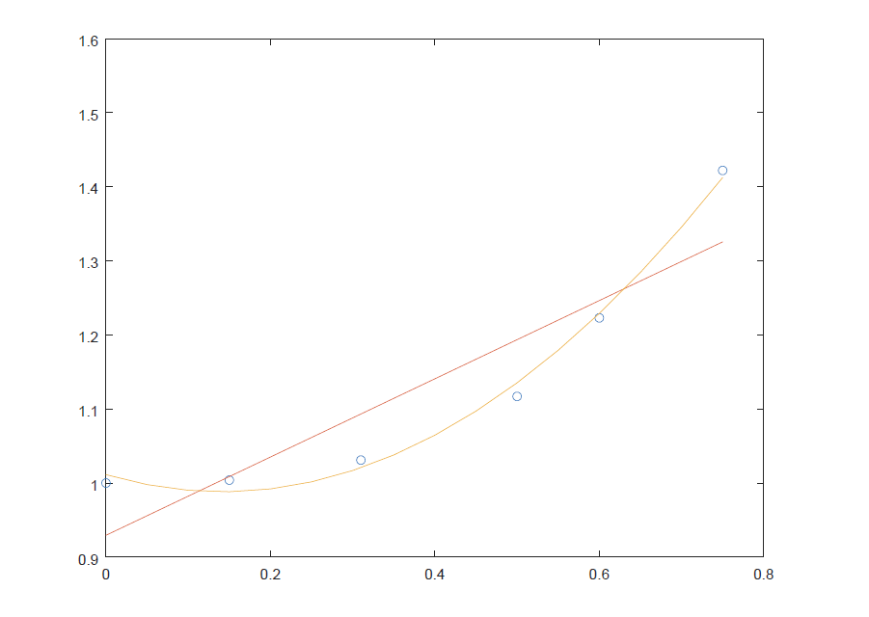

Plot 2:

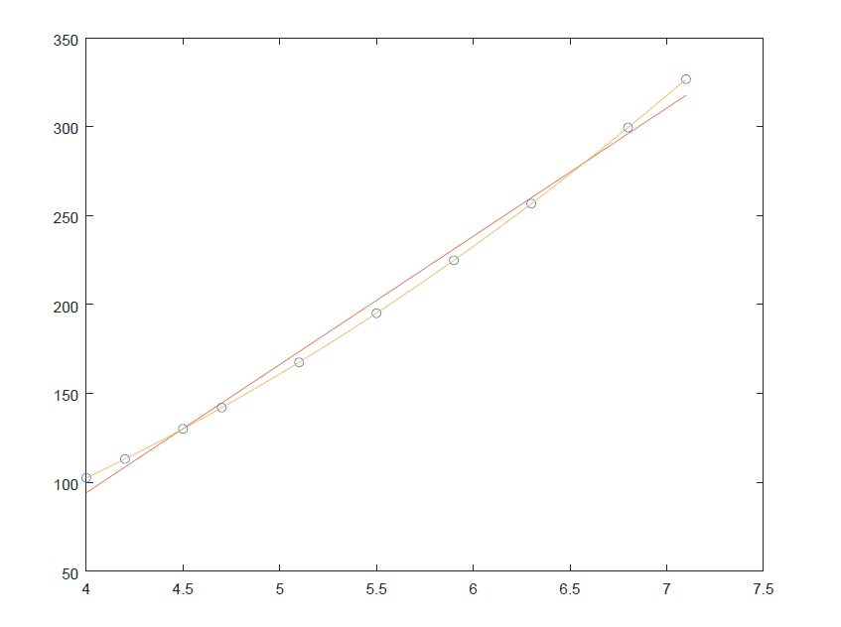

Plot 3:

